**if statements with multiple matching conditions**

1)Getinput

Commands

vi getinput.sh (creating a script File)

#!/bin/bash

echo 'Who are you?'

read who

echo "Hello, $who!"

Output

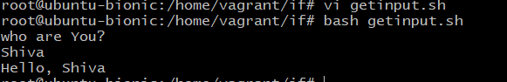

2) IF, Else statement

Example 1:

Commands

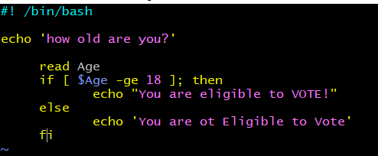

Output:

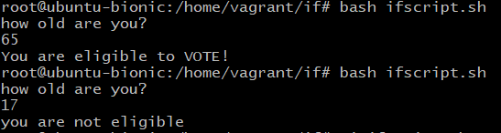

3) If, else

Example 2:

To check whether the candidates are eligible to applying for College course by their 12th Marks percentage

Commands

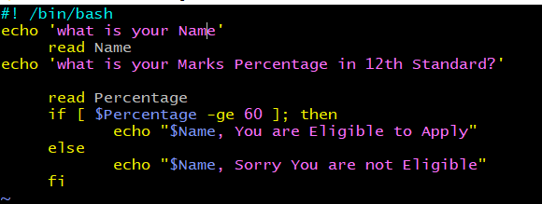

Output

